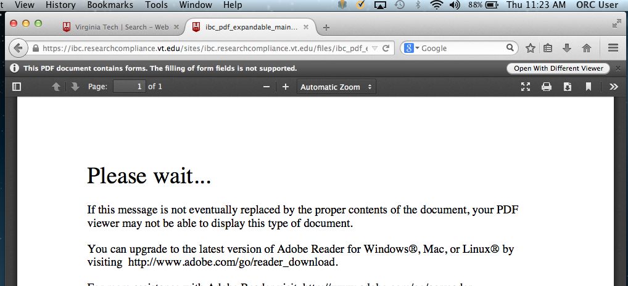

Click this icon

A. In Firefox and Internet Explorer:

B. In Safari:

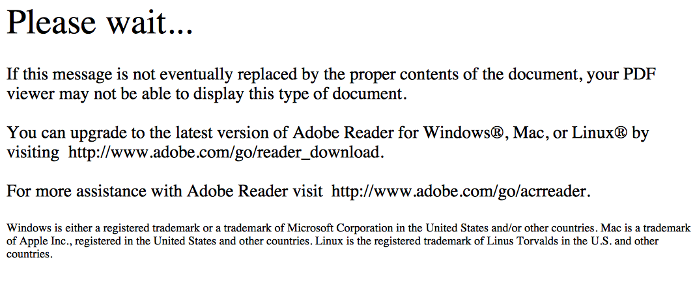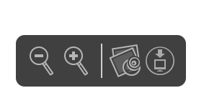

Place the cursor towards the bottom of the page and Click this icon

C. In Chrome:

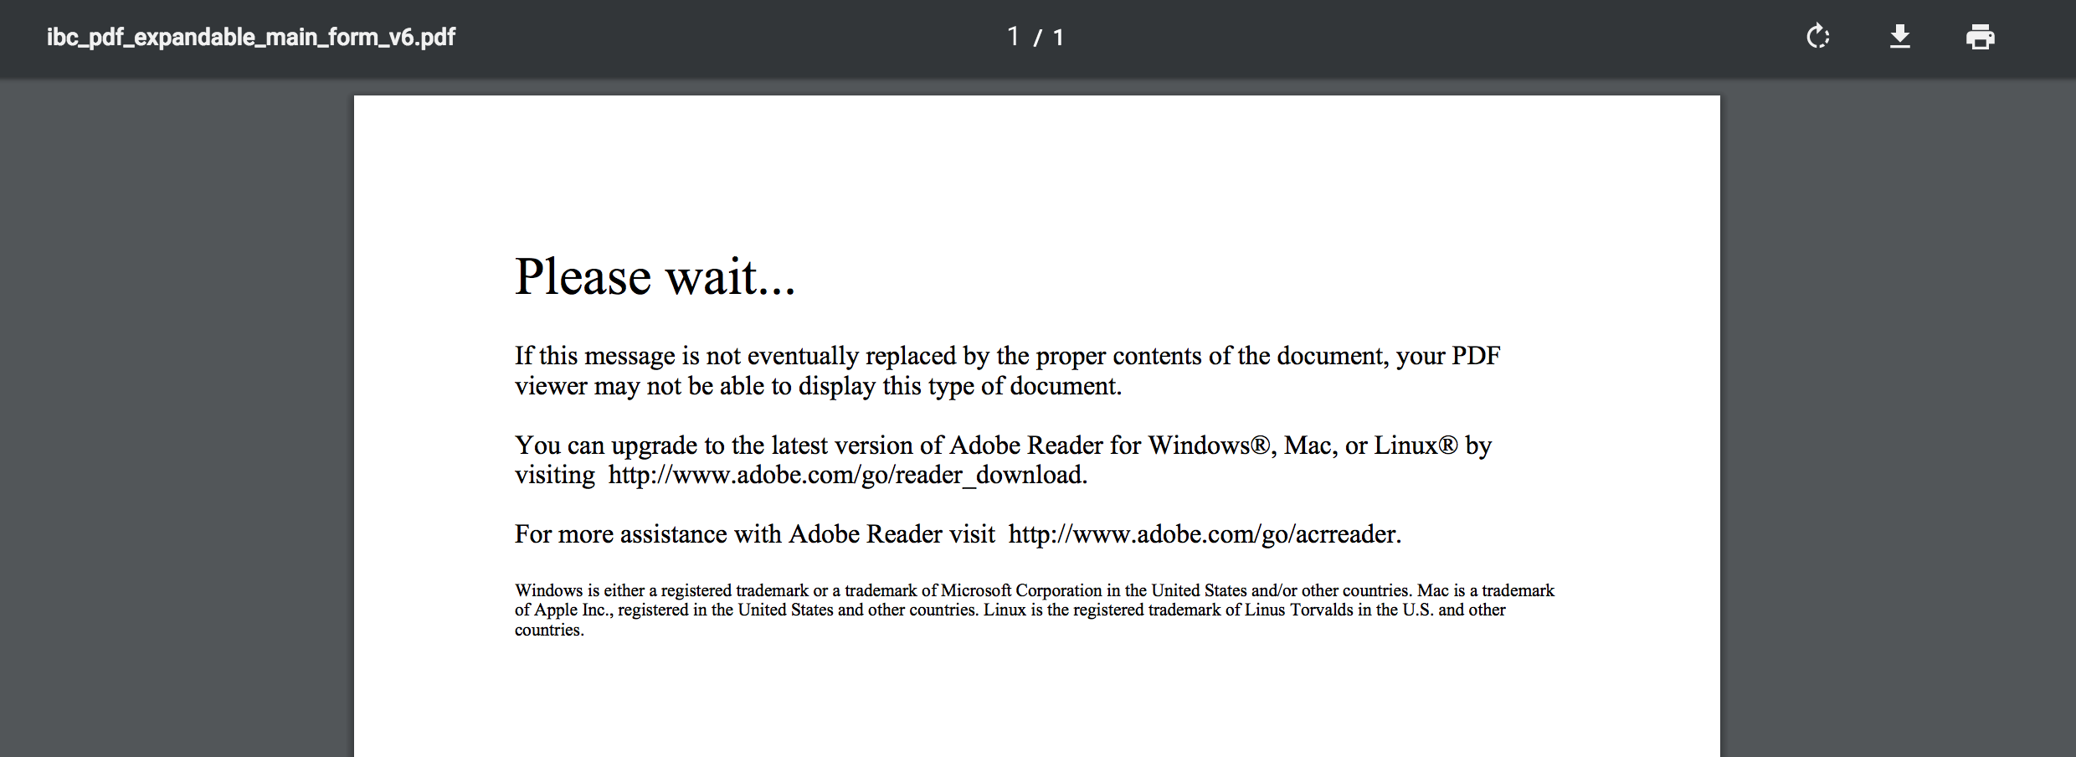

Click this icon. A “save as” window will open. Save onto your desktop.

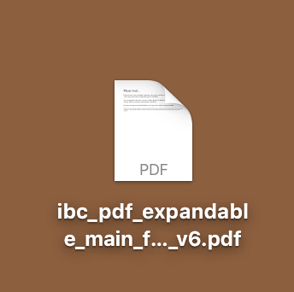

Although the icon will look like the error message, if you double-click on it the form will open correctly.