Standard Operating Procedure:
Handling Genetically Modified Drosophila melanogaster

Purpose

The purpose of this standard operating procedure (SOP) is to define techniques and procedures that allow for the storage and handling of all life stages of genetically modified D. melanogaster while reducing accidental release/exposure.
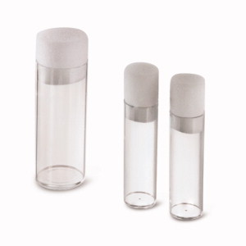
Figure 1. Polypropylene plastic rearing vessel that serves as the primary container to rearing D. melanogaster.

Storage of Genetically Modified Organisms

Double storage containers are required to store all genetically modified D. melanogaster strains, which are defined as strains that do not occur in nature. Genetically modified strains do not include wild-type (e.g. Oregon-R) or mutations that naturally occur (e.g. strains 111 or 1675). D. melanogaster strains will be reared according to general procedures. Briefly, flies are reared in polypropylene vessels, which serve as the primary container (Figure 1). Rearing vessels are sealed with plugs that are permeable to air, but not to flies at any life stage (Figure 1). Each vial must be labeled with the strain, identification number (Bloomington stock number), date (corresponds to the date the media and flies were added to the rearing vessel), and initials of the lab member that started the new vial. Vials containing strains of D. melanogaster must be stored in a secondary container, which is a 2.5-quart modular latch Sterilite® container. The secondary container (Figure 2) has been modified with portions of the plastic removed from the lid or side of the container. These openings of the secondary container are sealed with fine (organza-type) mesh, which allows the movement of air into and out of the secondary container while the mesh prevents the release of flies. These secondary containers should be clear of any debris (i.e. dead flies or food) on the floor of the container at all times. Prior to opening the secondary container, visual inspection of the bottom and side of the container must be performed to ensure there is not a failure of the primary vessel (i.e. release of adult flies).

The reporter and drive fly strains must remain separated from each other. When driver and reporter fly strains are being mated, they must be segregated into a different secondary container, which is labeled appropriately.
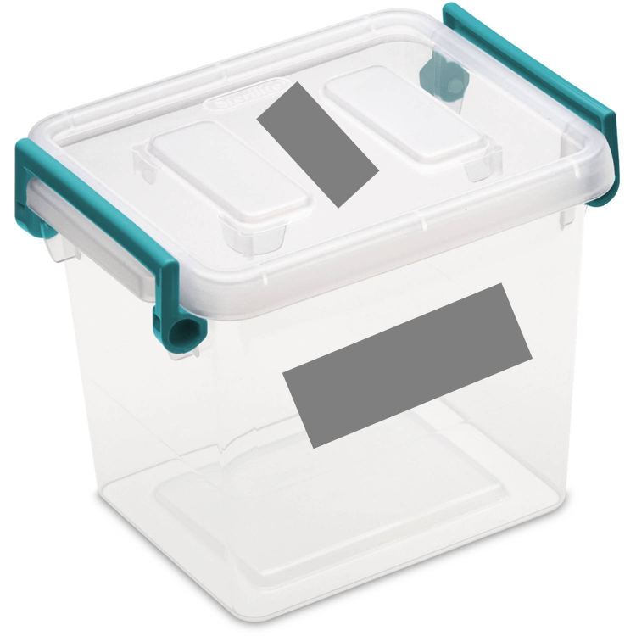
FIGURE 2. Secondary container that will hold D. melanogaster. The grey rectangles indicate pieces of the container that have been removed and covered with an organza-like cloth allowing the movement of air into the secondary container.

Handling Genetically Modified D. melanogaster
Carbon dioxide will be used to anesthetized genetically modified flies. This will be achieved using The Flowbuddy benchtop flypad and blowgun (Figure 3). The flies are anesthetized by inserting the nozzle of the blowgun between the vial wall and the plug. The role of the blowgun is to apply carbon dioxide without releasing any adult flies. Once the flies are anesthetized, they can be moved to the fly pad, which delivers a constant level of carbon dioxide to perform procedures on adult flies. Carbon dioxide anesthesia is not needed for non-flying life stages.
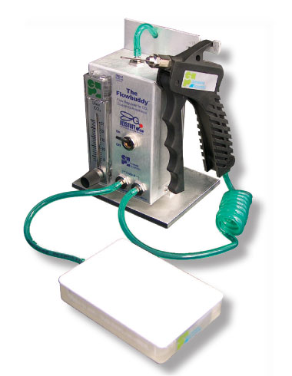
Figure 3. Benchtop flowbuddy system, which is used to anesthetizing flies while reducing the accidental release of adult flies.

Disposing of Genetically Modified Flies
All insects, including wild-type and genetically modified, must be frozen for 24 hr at -20ºC or -80 ºC. Once frozen, the genetically modified flies (all life stages) and media shall be placed into a BSL-1 (clear autoclavable bag), and autoclaved for an appropriate amount of time to perform mechanical destruction of all genetically modified flies. Dispose of GMO flies as RMW after autoclaving. The D. melanogaster fly rearing vessel can be washed using soapy water, rinsed with regular water followed by DI water (NO ACETONE). The secondary container should be washed at a frequency of once a week.

Procedure for Accidental Release of Genetically Modified Flies

All work needs to be performed in the proximity of an electronic fly swatter, which can be used to electrocute any accidentally release fly. Additionally, vinegar will be present in the laboratory, which can be used as a source to attract, and drown, accidentally release flies.

